Приложение 7 к Протоколу заочного голосования Организационного комитета Международной олимпиады Ассоциации «Глобальные университеты» для абитуриентов магистратуры и аспирантуры от 20.06.2023 № 1-з
Структура научного профиля (портфолио) потенциальных научных руководителей участников трека аспирантуры Международной олимпиады Ассоциации «Глобальные университеты» для абитуриентов магистратуры и аспирантуры.

На английском языке:

University | Sechenov University
Level of English proficiency | C1
Educational program and field of the educational program for which the applicant will be accepted | 31.05.03 Dentistry (educational program)  31.08.74 Oral surgery (field of the educational program)
List of research projects of the potential supervisor (participation/leadership) | 1) Optimization of diagnosis and treatment of arteriovenous malformations of head and neck with the use of MSCT-angiography (2015)  2) Comparative analysis of methods to increase ﻿the amount of keratinized mucosa before stage-two surgery: a randomized controlled study (2020) Tarasenko S, Ashurko I, Taschieri S, Repina S, Esaya N A, Corbella S.
List of the topics offered for the prospective scientific research | 1) Prevention of complications of removal of third molars of the mandible  2) Surgical treatment of inflammatory periodontal diseases optimization  3) Studying the possibilities of surgical dental laser in the treatment of oral diseases  4) Studying the possibilities of using artificial intelligence in the diagnosis and treatment planning of oral surgical diseases  5) Improving the treatment of alveolitis in patients of various groups  6) Use of various methods of wound closure in oral surgery  7) Studying the capabilities of CBCT, OPTG, ultrasound in the diagnosis and treatment planning of surgical pathology of the oral cavity
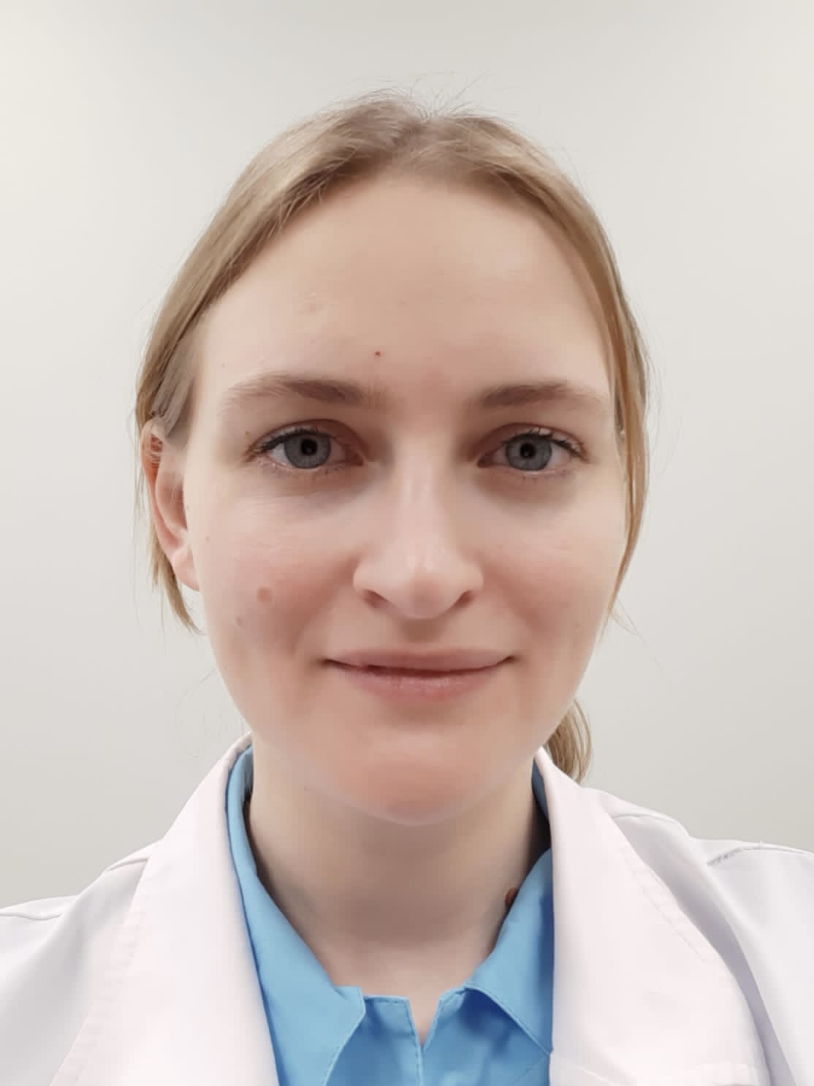Фото  Research supervisor:  Svetlana I. Repina  Candidate of Science (Moscow State University of Medicine and Dentistry) | FY DENTISTRY, ORAL SURGERY & MEDICINE Стоматология и хирургическая стоматология
Supervisor’s research interests
Improving the diagnosis and treatment of periodontal diseases and inflammatory diseases of peri-implant tissues
The use of laser technologies in oral surgery
Prevention of complications during tooth extraction
Relationships between oral diseases and somatic pathology
Research highlights (при наличии)
No
Supervisor’s specific requirements:
Completion of training in the use of surgical lasers in dentistry
Fluency in Russian and English
Working with medical statistics
Total amount of publications in journals indexed by Web of Science, Scopus, RSCI for the last 5 years: 8
Supervisor's main publications:
Tarasenko S.V., Tsarev V.N., Garipov R.D., Dyachkova E.Yu., Repina S.I. MICROBIOLOGICAL RATIONALE AND EFFECTIVENESS OF USE OF ERBIUM AND NEODYMIUM LASERS IN PATIENTS WITH INFLAMMATORY DISEASES OF PERIODONTAL AND PERI-IMPLANT TISSUE Clinical dentistry. 2019. No. 4 (92). pp. 41-45. (Scopus, RSCI)
Tarasenko S., Ashurko I., Taschieri S., Repina S., Esayan A., Corbella S. COMPARATIVE ANALYSIS OF METHODS TO INCREASE THE AMOUNT OF KERATINIZED MUCOSA BEFORE STAGE-TWO SURGERY: A RANDOMIZED CONTROLLED STUDY Quintessence International. 2020. T. 51. No. 5. P. 374-387. (Scopus)
Garipov R., Davtyan A., Diachkova E., Volkova M., Repina S., Tarasenko S. EFFICIENCY AND MICROBIOLOGICAL SUBSTANTIATION OF THE USE OF ER:YAG AND ND:YAG LASERS IN PATIENTS WITH INFLAMMATORY DISEASES OF THE PERI-IMPLANT AND PERIODONTAL TISSUE Biointerface Research in Applied Chemistry. 2020. T. 11. No. 3. P. 10141-10147. (Scopus)
Volchkova I.R., Yumashev A.V., Kristal E.A., Borisov V.V., Doroshina V.I., Repina S.I. INFLUENCE OF REMOVABLE DENTURE CLEANING AGENTS ON ADHESION OF ORAL PATHOGENIC MICROFLORA IN VITRO: A RANDOMIZED CONTROLLED TRIAL Open Dentistry Journal. 2020. T. 14. No. 1. P. 656-664. (Scopus)
Tarasenko S.V., Ippolitov E.V., Tsarev V.N., Muravyov N.V., Repina S.I. MICROBIOCENOSIS OF EXTRACTED TEETH SUNES IN PATIENTS WITH ALVEOLITIS Head and Neck. Russian edition. Journal of the All-Russian public organization Federation of specialists in the treatment of head and neck diseases. 2022. T. 10. No. S2S2. pp. 14-16. (Scopus)
Results of intellectual activity (при наличии)
Repina, Svetlana Igorevna. Optimization of diagnosis and treatment of arteriovenous malformations of the head and neck using MSCT angiography: dissertation ... Candidate of Medical Sciences: 01/14/13 01/14/14 / Repina Svetlana Igorevna; [Place of defense: State budgetary educational institution of higher professional education "Moscow State Medical and Dental University named after A.I. Evdokimov" of the Ministry of Health of the Russian Federation]. - Moscow, 2015. - 160 p.: ill.

