Приложение 7 к Протоколу заочного голосования Организационного комитета Международной олимпиады Ассоциации «Глобальные университеты» для абитуриентов магистратуры и аспирантуры от 20.06.2023 № 1-з
Структура научного профиля (портфолио) потенциальных научных руководителей участников трека аспирантуры Международной олимпиады Ассоциации «Глобальные университеты» для абитуриентов магистратуры и аспирантуры.
University | I.M. Sechenov First Moscow State Medical University (Sechenov University) is the top medical university in Russia. Its history begins in 1758 as the medical faculty at Imperial Moscow University.
Level of English proficiency | B2
Educational program and field of the educational program for which the applicant will be accepted | 31.06.01 Clinical medicine (educational program)  3.1.20 Cardiology (field of the educational program)
List of research projects of the potential supervisor (participation/leadership) | 1. The executor under the grant of RSF №14-15-00360 2014-2016гг. "Development of a comprehensive algorithm for non-invasive diagnosis of vascular wall lesions at different levels of the vascular bed in patients with cardiovascular pathology and metabolic syndrome for the purpose of differentiated approach to management, risk stratification and prognosis of disease progression".  2. The executor under the gran RFBR № 18-515-76002 "The neuregulin-1 pathway in development and progression cardiovascular disease: identification of small molecule ErbB4 agonists and identification of patient populations that could benefit the most".  3. The executor under the gran RFBR № 18-015-00415 "Working out of personalized early diagnostic techniques and predictive criteria of the course of hypertrophic cardiomyopathy based on microRNA-21 and RNA-133 analysis that reflex hypertrophy and myocardial fibrosis degree".  4. The executor under the gran RFBR № 18-315-00135 "Development of an algorithm for early detection and possible prediction of the endothelial dysfunction in patients with metabolic syndrome, using metabolic profiling"  Participation in the clinical trials  - PROSPECTIVE OBSERVATIONAL MULTICENTER REGISTER STUDY OF PATIENTS WITH CHRONIC HEART FAILURE IN THE RUSSIAN FEDERATION (PRIORITY-CHF) 2021- present – Principal Investigator  - ESC/EORP Heart Failure III registry 2019-2020 – Co-investigator  - CL3-05520-005 2014-2016 - Co-investigator (phase 3)  - FER-CARS- 04 2014-2016 -Co-investigator (phase 3)  2021-2022 – Visiting Lecture of the Surrey University, United Kingdom
List of the topics offered for the prospective scientific research | 1. Use of digital technologies for remote monitoring of patients with chronic diseases.  2. Machine learning in remote digital monitoring of patients with chronic diseases.  3. Metabolomic profiling in the diagnosis of cardiovascular diseases.  4. Physical activity as method of treating patients with chronic heart failure and obesity.  5. Phenotyping of patients with chronic heart failure with preserved ejection fraction.  6. Relationship between metabolomic profile and miRNA in patients with chronic heart failure.  7. Personalized approach to individual cases of heart failure.
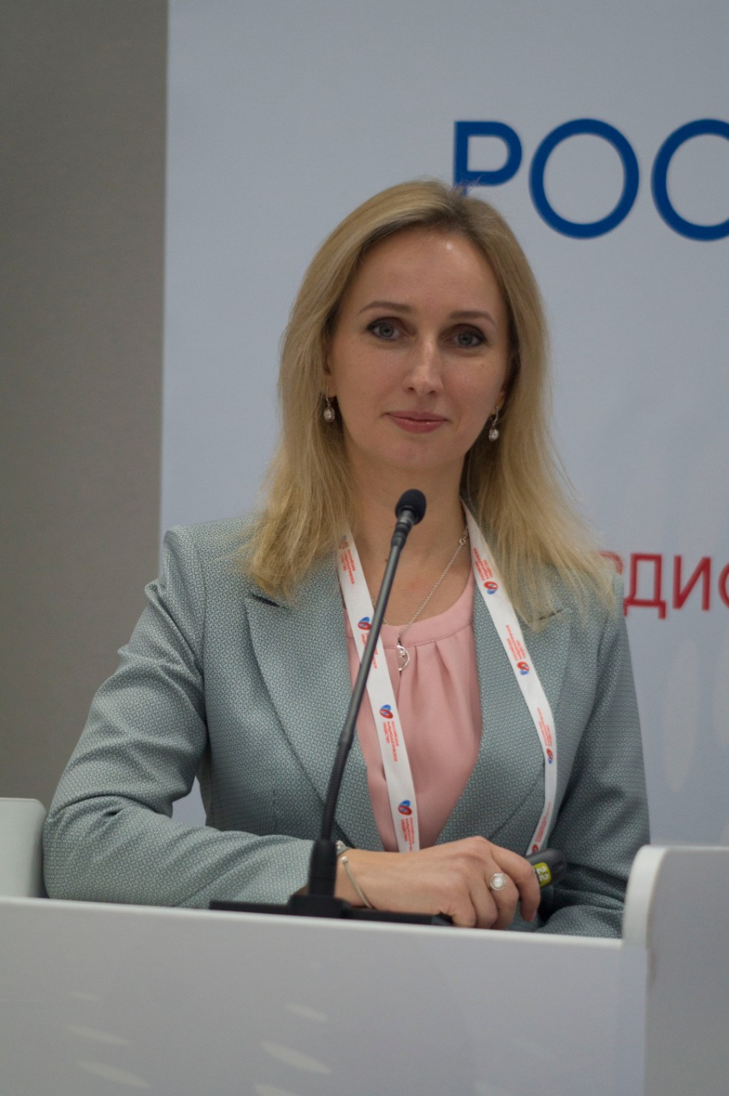  Research supervisor:  Maria V. Kozhevnikova,  Candidate of Science (Sechenov University) | DQ  CARDIAC&CARDIOVASCULARSYSTEMS
Supervisor’s research interests
Since February 2021 - the head of the Scientific and Practical "European Center for the Quality of Medical Care for Patients with Heart Failure (European Center-CHF)" organized on the basis of the Sechenov First Moscow State Medical University of the Ministry of Health of Russia (Sechenov University). In order to improve the patient monitoring system, a project was initiated in 2021 to create an information system for remote monitoring of the subjective state of patients. In 2022, a certificate of registration of the computer program 2022614185, 03/17/2022 was received. Application No. 2022613346 dated 01.03.2022. "Information system for remote monitoring of the subjective state of patients using personal messengers". Currently, the development is being actively introduced into the structure of the work of the Center for Monitoring Patients with CHF, work has begun on monitoring patients with rheumatoid arthritis.
Research highlights (при наличии)
Digital healthcare is one of the priorities of the National Healthcare Project. Research work in this area is relevant and promising. The system of remote monitoring of patients with chronic diseases developed by the staff of the department is currently being actively tested. Certificates of registration of the computer program have been obtained.
Supervisor’s specific requirements:
- Mandatory background of higher medical education in the field of General Medicine
- Background of clinical residency or internship
- Knowledge of methods of statistical data processing
- Supervisor’s main publications
- 28 publications
- Target Metabolome Profiling-Based Machine Learning as a Diagnostic Approach for Cardiovascular Diseases in Adults. Moskaleva NE, Shestakova KM, Kukharenko AV, Markin PA, Kozhevnikova MV, Korobkova EO, Brito A, Baskhanova SN, Mesonzhnik NV, Belenkov YN, Pyatigorskaya NV, Tobolkina E, Rudaz S, Appolonova SA. Metabolites. 2022 Nov 27;12(12):1185. doi: 10.3390/metabo12121185.
- Belenkov Yu.N., Kozhevnikova M.V. Mobile health technologies in cardiology. Kardiologiia. 2022;62(1):4-12. (In Russ.) https://doi.org/10.18087/cardio.2022.1.n1963
- Kozhevnikova M.V., Belenkov Yu.N. Biomarkers in Heart Failure: Current and Future. Kardiologiia. 2021;61(5):4-16. https://doi.org/10.18087/cardio.2021.5.n1530
- Surinder M. Soond , Maria V. Kozhevnikova , Paul A. Townsend, Andrey A. Zamyatnin, Jr. Integrative p53, micro-RNA and Cathepsin Protease Co-Regulatory Expression Networks in Cancer. Cancers 2020, 12(11), 3454; https://doi.org/10.3390/cancers12113454 SJR 1,94 Q1, ISSN20726694
- Kukharenko A, Brito A, Kozhevnikova MV, Moskaleva N, Markin PA, Bochkareva N, Korobkova EO, Belenkov YN, Privalova EV, Larcova EV, Ariani A, La Frano MR, Appolonova SA. Relationship between the plasma acylcarnitine profile and cardiometabolic risk factors in adults diagnosed with cardiovascular diseases. Clin Chim Acta. 2020 May 4;507:250-256. http://dx.doi.org/10.1016/j.cca.2020.04.035 SJR 0,88 , Q1, ISSN 00098981
Results of intellectual activity (при наличии)
Certificate of registration of the computer program No. 2022614185 "Information system for remote monitoring of the subjective state of patients using personal messengers"; Certificate of registration of the computer program No. 2022661895 "Platform for automatic validation of software for medical diagnostics based on artificial intelligence technologies"

