Приложение 7 к Протоколу заочного голосования Организационного комитета Международной олимпиады Ассоциации «Глобальные университеты» для абитуриентов магистратуры и аспирантуры от 20.06.2023 № 1-з
Структура научного профиля (портфолио) потенциальных научных руководителей участников трека аспирантуры Международной олимпиады Ассоциации «Глобальные университеты» для абитуриентов магистратуры и аспирантуры.
University | Sechenov University
Level of English proficiency | fluent
Educational program and field of the educational program for which the applicant will be accepted | 31.06.01 Clinical medicine (educational program)  3.1.14. “Organ transplantation and artificial organs” (profile of the educational program)
List of research projects of the potential supervisor (participation/leadership) | clinical medicine, organ transplantation transplantology and artificial organs, cardiac transplantation, terminal heart failure, clinical cardiology, non-invasive diagnostics and management of critical heart failure and cardiac recipients, challenges and implications of mechanical circulatory support devices
List of the topics offered for the prospective scientific research | List of 7-10 scientific topics, which are offered by the research supervisor for consideration of foreign applicants:  prevention and risk stratification of adverse events and quality of life critical heart failure patients; researches in the field of mechanical circulatory support devices; prevention of perioperative complications in cardiac recipients; non-invasive predictors and risk factors, prevention, and treatment of systemic hypertension, transplant coronary artery disease, post-transplant nephropathy, post-transplant diabetes mellitus, cancer prevention in chronic immunosuppression, mental health and active longevity in heart recipients and mechanical circulatory support devices patients
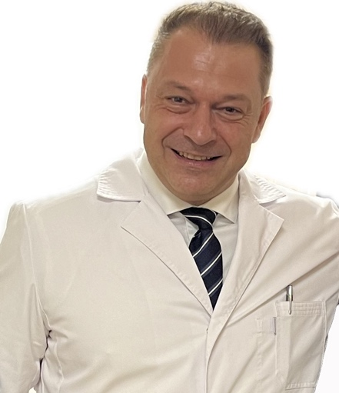  Research supervisor:  Professor Alex O Shevchenko (Chevtchenko)  MD, PhD, ScD, Professor, Corresponding Fellow of the Russian Academy of Sciences | 3.03 Health sciences:  PY - MEDICINE, GENERAL & INTERNAL;  YP- TRANSPLANTATION (Трансплантология);  DQ - CARDIAC & CARDIOVASCULAR SYSTEMS
Supervisor’s research interests
organ transplantation, cardiac transplantation, clinical cardiology, transplantomics, individualized approaches to the long-term prognosis, quality of life functional status of solid organ recipients,development and clinical research of mechanical circulatory support devices, outcome predictors and management of critical heart failure patients, in particular - non-invasive laboratory proteomic and genetic markers and instrumental diagnosis of asymptomatic manifestations of life-threatening conditions
Research highlights
research in the field of clinical medicine, cardiology, at the intersection of therapy, cardiac surgery, and transplant medicine; involving patients with life-threatening conditions; with the use of the recent clinical, instrumental and laboratory research methods; based on a leading world-class clinical center facility
Supervisor’s specific requirements:
clinical experience in general practice, cardiology, emergency care, basic knowledge in the field of cardiac surgery, organ transplantation and immunosuppression; understanding of current trends in the field of transplant medicine; motivated and hard-working personality with great learning capacity
Supervisor’s main publications
Above 250 articles and monographs, of which 85 within the last 5 years, among them:
- ARTIFICIAL HEART IN RUSSIA: PAST, PRESENT, AND FUTURE. Gautier S.V., Shevchenko A.O., et al. Artificial Organs. 2020.
- MECHANISMS, EPIDEMIOLOGY, AND CLASSIFICATION OF ACUTE KIDNEY INJURY IN CARDIAC TRANSPLANT RECIPIENTS. Poz Ya.L., Strokov A.G., Poptsov V.N., Shevchenko A.O., Gauthier S.V. Bulletin of transplantology and artificial organs. 2021. T. 23. No. 2. P. 147-157.
- MALIGNANT COMPLICATIONS OF IMMUNOSUPRESSION IN CARDIAC RECIPIENTS. Krugly L.B., Koloskova N.N., Nikulin A.V., Pashkov I.V., Poptsov V.N., Shevchenko A.O. Bulletin of transplantology and artificial organs. 2021. T. 23. No. 2. P. 167-176.
- ANTIBODY-MEDIATED REJECTION OF HEART TRANSPLANT. Kvan V.S., Koloskova N.N., Kachanova Yu.A., Sayfullina N.N., Goncharova A.Yu., Krugly L.B., Shevchenko A.O.
Bulletin of transplantology and artificial organs. 2021. T. 23. No. 4. P. 47-61.
- CORONAVIRUS COVID-19 INFECTION IN HEART, KIDNEY, LIVER RECIPIENTS: FIRST RESULTS OF THE NATIONAL MULTICENTER OBSERVATIONAL STUDY "ROKKOR-RECIPIENT". Gauthier S.V., Shevchenko A.O., et al. Bulletin of transplantology and artificial organs. 2020. T. 22. No. 3. P. 8-17.
Results of intellectual activity
Above 250 articles and monographs, and 14 patents

