Приложение 7 к Протоколу заочного голосования Организационного комитета Международной олимпиады Ассоциации «Глобальные университеты» для абитуриентов магистратуры и аспирантуры от 20.06.2023 № 1-з

Структура научного профиля (портфолио) потенциальных научных руководителей участников трека аспирантуры Международной олимпиады Ассоциации «Глобальные университеты» для абитуриентов магистратуры и аспирантуры.

University | ФГАОУ ВО Первый МГМУ им. И.М. Сеченова Минздрава России (Сеченовский Университет)
Level of English language proficiency | B2
The direction of training for which the graduate student will be accepted | Basic medical research, Physiology
List of research projects of a potential supervisor (participation/guidance) | 1. R&D contract, SIBARITIC, Inc. (USA): Effects of adaptation to dose-dependent hyperthermia on physiological endurance, cardiovascular and endocrine status in virtually healthy volunteers (with assessment of brain-derived neurotropic factor (BDNF) and heat shock protein groups (HSPs) dynamics (2015-2018, supervisor).  2. RFBR grant, Project 17-06-00784 Quality of life of elderly patients with cardiovascular pathology: impact of interval hypoxia-hyperoxia adaptation procedures (2017-2018, supervisor).  3. RFBR grant, Project 19-07-00008 A "Development of information technology for recognition of true and false mental responses in brain mental activity based on analysis of electroencephalograms by wavelet transforms and machine learning methods. (2019-2021, executor).  3. RFBR grant, Project 19-013-00465 A "Direct and cross-sectional effects of adaptation to systemic hyperthermia: effects on quality of life, neurohormonal and psychophysiological status in humans" (2019-2021, supervisor).
List of possible research topics | 1. Effect of acute hypoxia and a course of hypoxic conditioning procedures on carbohydrate homeostasis in subjects with reduced glucose tolerance.  2. Direct and cross-sectional effects of healthy human adaptation to interval hypoxia.  3. Reproducibility of normobaric hypoxia tolerance test as a criterion of adaptive capacity and rehabilitation efficiency in patients with chronic pathology  4. Comparative analysis of effectiveness of hypoxic conditioning in different modes on human oxidative status
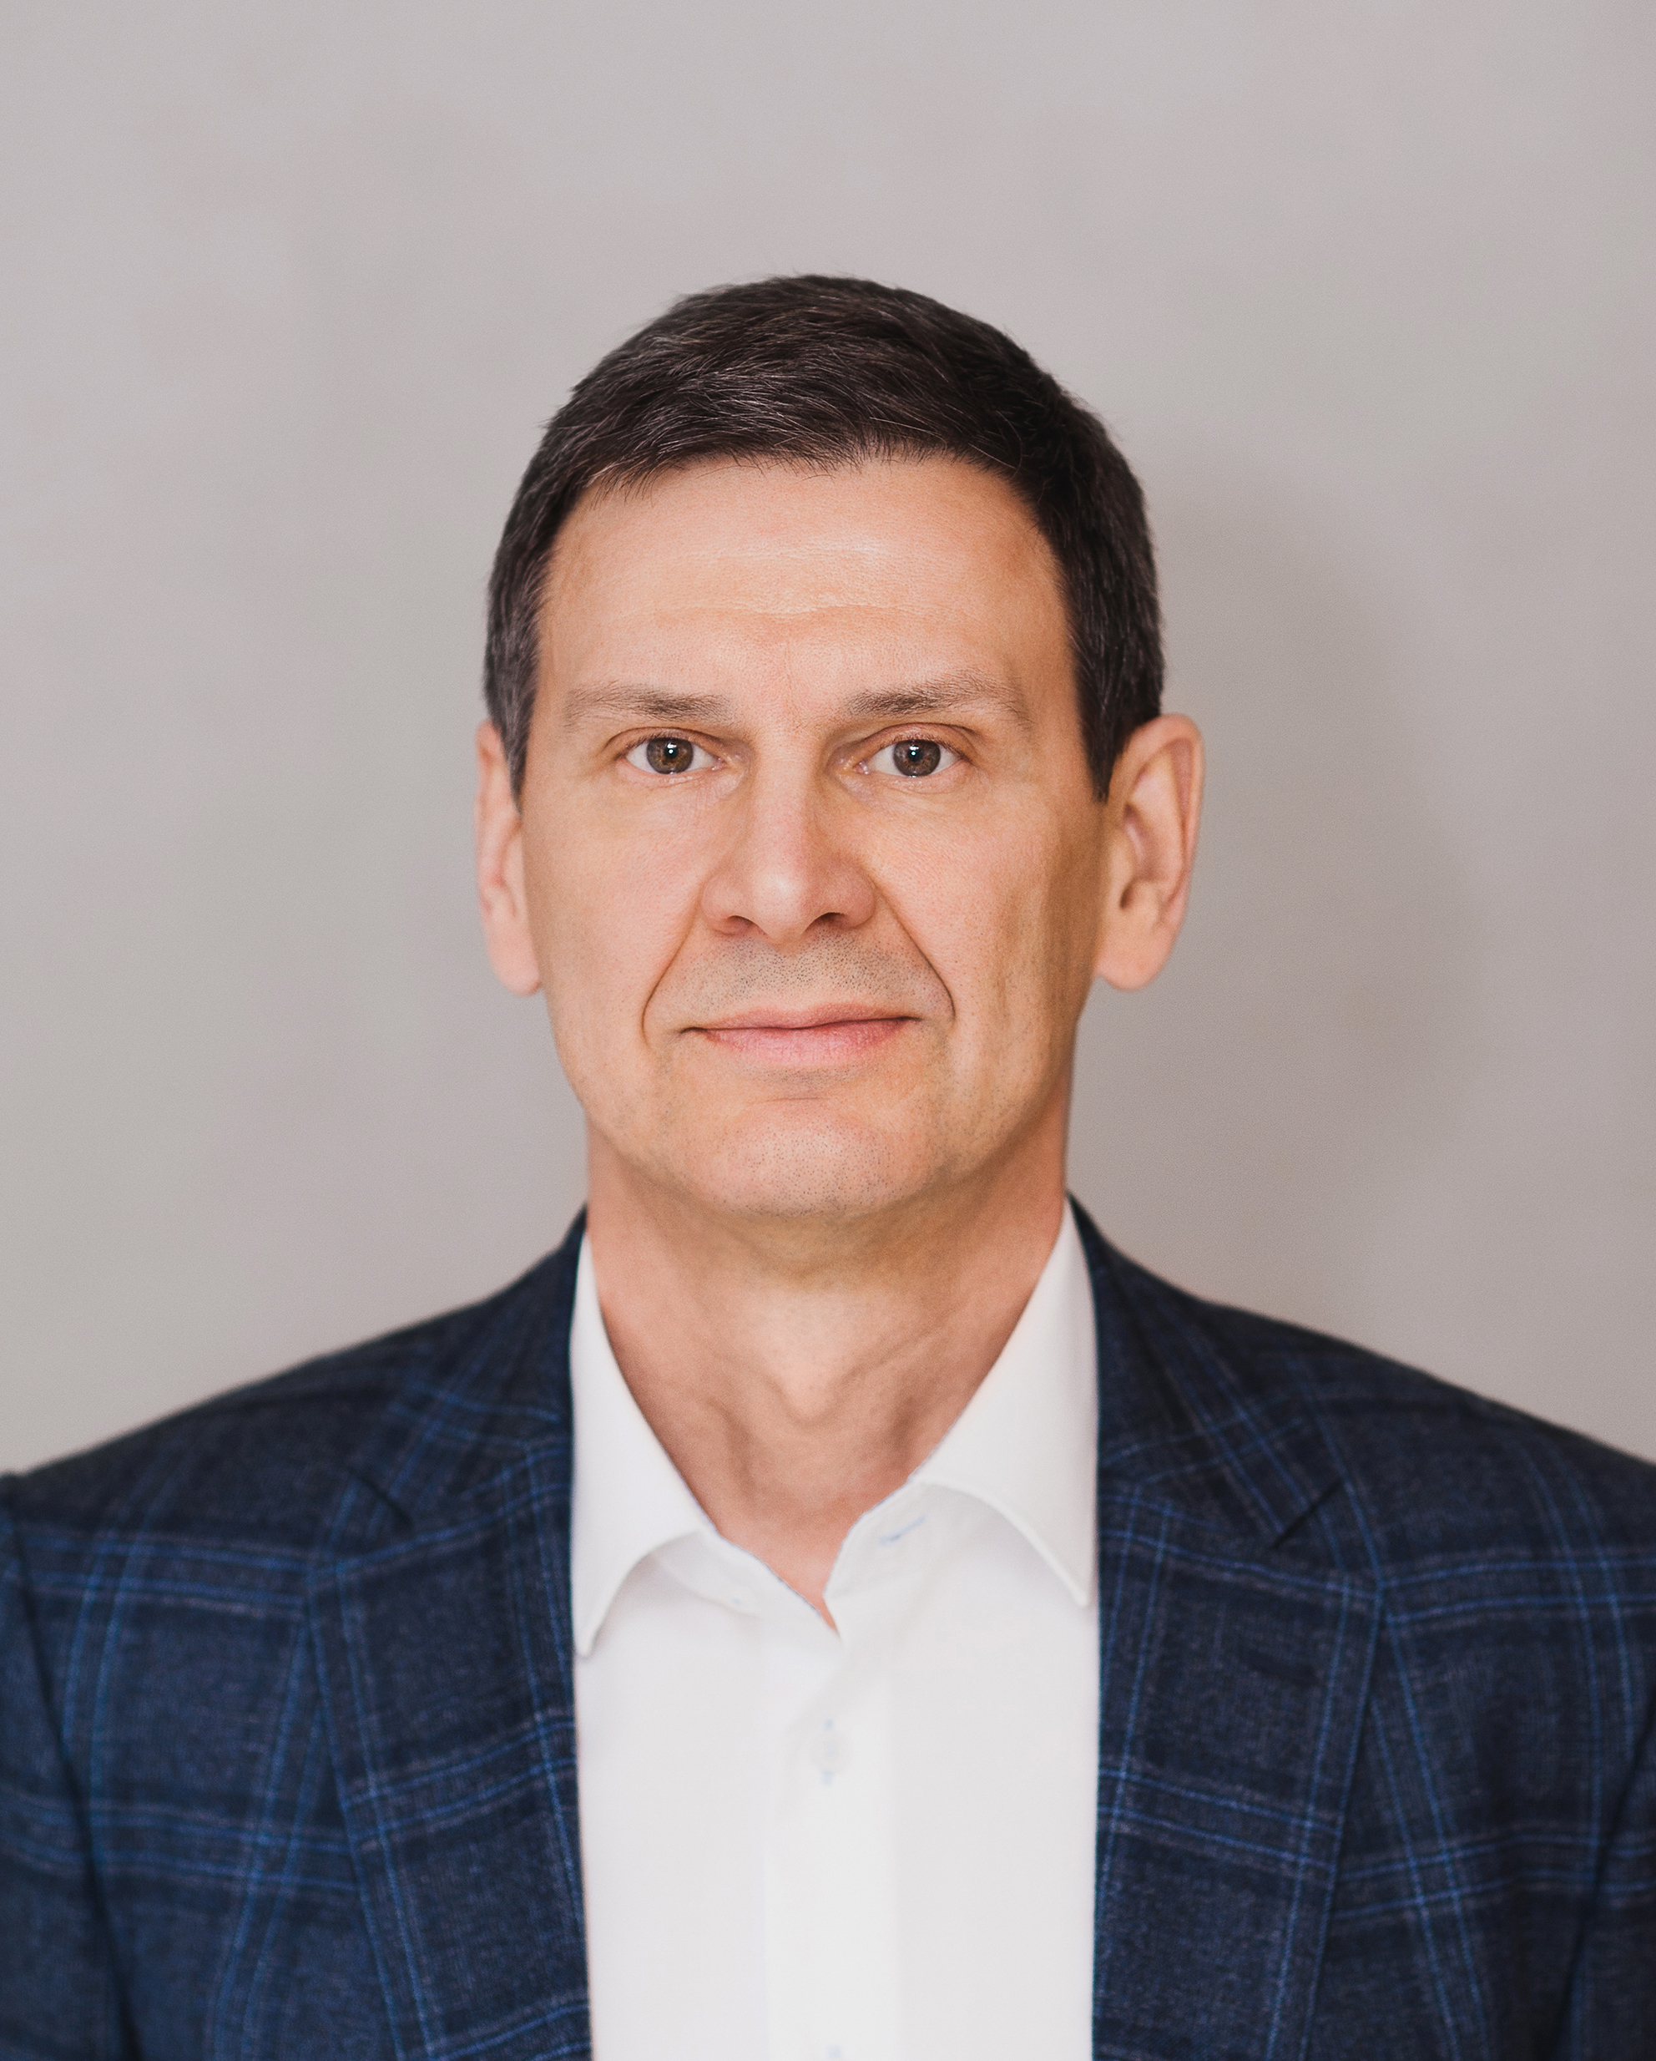  Research supervisor:  Oleg S. Glazachev,  Doctor of Science/PhD (P.K.Anokhin Research Institute of Normal Physiology, RAMS) | MEDICAL AND HEALTH SCIENCES 3.01 Basic medical research, Physiology
Supervisor's research interests (more detailed description of research interests): The main scientific field is the study of system mechanisms of stress development and human adaptation to natural and preformed environmental factors with the aim of their directed application for the development of functional reserves. Fundamental regularities of redox-signal mechanisms of adaptation to stress factors are revealed and new approaches to application of hypoxic-hyperoxic gas mixtures, complex temperature influences, as well as their hardware implementation for treatment and rehabilitation of different categories of patients and professional athletes are developed. The basic mechanisms of human adaptation cross-effects on the basis of application of gas mixtures with different oxygen content as well as interval hyperthermic stimuli have been studied. Probable mechanisms of muscle-brain relations during hyperthermic stimuli mediated by induction of myokines (irisin and MNTF) were revealed.
In various model situations, a principal possibility of probabilistic detection of the human brain state based on the dynamic wavelet analysis of the EEG has been established.
On the basis of the completed scientific projects together with the industrial partner the devices and software for interval hypoxic-hyperoxic exposure were developed and tested, clinical research on the introduction of technology in rehabilitation programs and maintaining quality of life of elderly multimorbid patients, patients with cardiac pathology was conducted. Algorithms for individual dosing of hypoxic stimuli based on the biofeedback principle were created.
Research highlights (при наличии):
There are state-of-the-art methods for collecting and digitally processing physiological signals, original apparatuses for individuating hypoxic-hyperoxic gas mixtures, hyperthermic stimuli, express analysis of human pro-oxidant-antioxidant status, a collaboration with the University of Magdeburg (Germany) has been established and is running well.
Supervisor’s specific requirements:
- The candidate has mastered human physiology, physical examination of patients, MS Office software, Statistica, literature, databases.
Supervisor’s main publications 28:
- Bayer U., Likar R., Pinter G., Stettner H., Demchar S., Trummer B., Neuwerch S., Glazachev O., Burtcher M. Effects of a Multimodal Training Intervention combined with Intermittent Hypoxia-Hyperoxia on Mobility and Quality of Life in Geriatric Patients: A randomized controlled trial. BMC Geriatrics. 2019; 8: 167. doi.org/10.1186/s12877-019-1184-16, Q1, SJR=1,15
- Glazachev O.S., Zapara M.A., Dudnik E.N., Samartseva V.G., Susta D. Repeated hyperthermia exposure increases circulating Brain Derived Neurotrophic Factor levels which is associated with improved quality of life, and reduced anxiety: A randomized controlled trial. Journal of Thermal Biology, 2020; 89: 102482. https://doi.org/10.1016/j.jtherbio.2019.102482, Q1, SJR=0,64
- Behrendt T., Bielitzki R., Behrens M., Glazachev O.S. and Schega L. Effects of Intermittent Hypoxia-Hyperoxia Exposure Prior to Aerobic Cycling Exercise on Physical and Cognitive Performance in Geriatric Patients—A RandomizedControlled Trial. Front. Physiol. 2022. 13:899096.doi: 10.3389/fphys.2022.899096, Q1, SJR=1,13
- Bestavashvili A.A., Glazachev O.S., Bestavashvili Al.A., Dhif I., Suvorov A.Yu., Vorontsov N.V., Tuter D.S., Gognieva D.G., Zhang Y., Pavlov C.S., Glushenkov D.V., Sirkina E.A.,Kaloshina I.V., Kopylov Ph.Yu. The Effects of Intermittent Hypoxic–Hyperoxic Exposures on Lipid Profile and Inflammation in Patients With Metabolic Syndrome. Front. Cardiovasc. Med. 2021; 8:700826. doi: 10.3389/fcvm.2021.700826, Q1, SJR=1,44
- Mallet R., Burtscher I., Manukhina E., Downey F., Glazachev O., Serebrovskaya T., Burtscher M. The Neuroscience of Dementia: Diagnosis and Management in Dementia. Ed. By C.R. Martin and V.R.Preedy. Elsevier Inc (ISBN 978-0-12-815854-8). Chapter 47. Hypoxic-hyperoxic conditioning and dementia. pp 745-760.
Results of intellectual activity (при наличии)
- Lazebnik A.B., Zvenigorodskaya L.A., Glazachev O.S., Platonenko A.V., Spirina G.K., Dudnik E.N., Yartseva L.A., Mischenkova T.V. Method of non-drug treatment of metabolic syndrome. - The Russian Federation patent No2391121 of June 10, 2010 (Invention application No 2009103805, priority date February 05, 2009).
- Glazachev O.S., Platonenko A.V., Spirina G.K. Vorrichtung zur biologisch regelbaren Auswahl von individuellen Verlaufen für eine Interval-Hypoxie-Therapie (Hypoxietraining): Gebraushsmusters Nr. DE DE202012602, 06.08.2013; Tag der Eintragung 01.06.2012 Gebraushsmusterinhaber AI MEDIQ S.A., Luxembourg, LU (German utility patent)
- Yumatov E.A., Raevsky V.V., Pertsov S.S., Glazachev O.S., Dudnik E.N. Method and device of "symbiotic" hemofiltration for compensation of chronic renal insufficiency. - Patent of the Russian Federation № 2589658 dated 10.07.2016 (Invention application № 2015107421/14, 03.03.2015, decision on grant of patent dated 10.06.2016;)

