Приложение 7 к Протоколу заочного голосования Организационного комитета Международной олимпиады Ассоциации «Глобальные университеты» для абитуриентов магистратуры и аспирантуры от 20.06.2023 № 1-з
Структура научного профиля (портфолио) потенциальных научных руководителей участников трека аспирантуры Международной олимпиады Ассоциации «Глобальные университеты» для абитуриентов магистратуры и аспирантуры.
University | I.M. Sechenov First Moscow State Medical University (Sechenov University)
Level of English proficiency | C1
Educational program and field of the educational program for which the applicant will be accepted | 31.06.01 Clinical medicine (educational program)  31.05.03 Dentistry (field of the educational program)
List of research projects of the potential supervisor (participation/leadership) | Development of protocols for telemedicine. Optimization of tooth-preserving technologies. Development of modern treatments for patients with bone loss.
List of the topics offered for the prospective scientific research | - Experimental and clinical methods for individual dental intraosseous implants  - Clinical and biomechanical justification of the sparing method of implantation prosthetics  3. Use of laser technologies in implantology  4. Use of 3 D templates during tooth-preserving operations  5. Clinical and organizational methods for improving the effectiveness of telemedicine consultations  6.The use of robotics in implantology  7. Application of artificial intelligence in telemedicine consultations
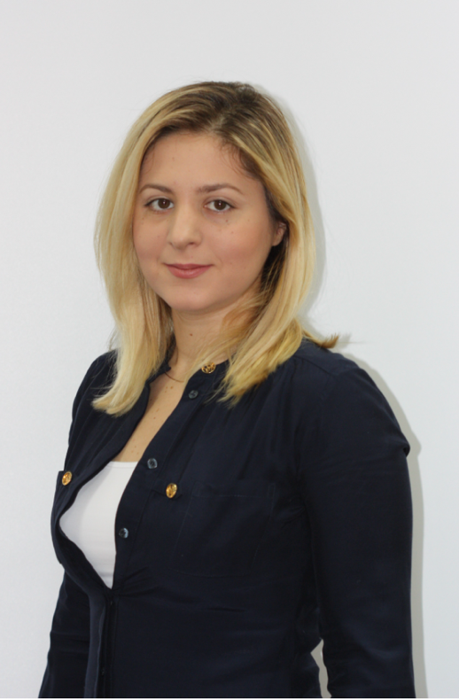  Research supervisor:  Ilana A. Gor,  Candidate of Science  I.M. Sechenov First Moscow State Medical University (Sechenov University) | MEDICAL AND HEALTH SCIENCES  FY DENTISTRY, ORAL SURGERY & MEDICINE
Supervisor’s research interests
trends in the development of digital technologies, evaluation of algorithms for the introduction of information and telecommunication and robotic technologies into clinical practice
Research highlights (при наличии)
Необходимо указать отличительные особенности данной программы, которые бы выделяли её перед остальными. (Использование уникального оборудования, взаимодействие с зарубежными учеными и исследовательскими центрами, финансовая поддержка аспиранта и т.д.)
Supervisor’s specific requirements:
Accreditation in the specialty Oral Surgery in the Russian Federation
Availability of international language certificate (level not lower than C1)
Knowledge of the basics of robotics and artificial intelligence
Practice by a dentist for at least 3 years
Fluency in computer and statistical software
Supervisor’s main publications
5
- Clinical efficacy of hydroxyapatite toothpaste containing Polyol Germanium Complex (PGC) with threonine in the treatment of dentine hypersensitivity
- Antibiotics Efficiency in the Infection Complications Prevention after Third Molar Extraction: A Systematic Review
Prevalence and structure of periodontal disease and oral cavity condition in patients with coronary heart disease (Prospective cohort study)
 | Results of intellectual activity (при наличии)

