APPROVED
by the protocol of the Organizing Committee of the International Olympiad of the Association of Educational Institutions of Higher Education "Global Universities" for graduate applicants for the degree of candidate of Science dated June 20, 2023 No. 1-z

The structure of the scientific profile (portfolio) of potential scientific supervisors of the participants of the International Olympiad of the Association "Global Universities" on the track of postgraduate studies in 2023-2024.
University | Federal State Autonomous Educational Institution of Higher Education I.M. Sechenov First Moscow State Medical University of the Ministry of Health of the Russian Federation (Sechenov University)
Level of English language proficiency | Upper intermediate
The direction of training for which the graduate student will be accepted | 3.02 Clinical medicine. Orthopedics.
Code of the field of study for which the graduate student will be accepted | 3.02 Clinical medicine. Orthopedics.
List of research projects of a potential supervisor (participation/guidance) | Bobrov D.S., Shubkina A.A., Lychagin A.V., и др. Surgical treatment of hammertoes (literature review) // Annals of the Russian academy of medical sciences. - 2019. - Т. 74. - №4. - C. 272-282. doi: 10.15690/vramn1096.  Serova N.S., Belyaev A.S., Bobrov D.S., Babkova A.A., Karev A.S. Role of functional MSCT in the diagnosis of elastic flatfoot deformity. REJR 2019; 9(2):301-314. DOI:10.21569/2222-7415-2019-9-2-301-314.  Лычагин А.В., Гаркави А.В., Ислейих О.И., Катунян П.И., Бобров Д.С., Явлиева Р.Х. и др. Эффективность внутрикостного введения аутологичной обогащенной тромбоцитами плазмы в зону отека костного мозга при остеоартрозе коленного сустава . Вестник РГМУ. 2019; (4): –. DOI: 10.24075/vrgmu.2019.053.  Serova N.S., Belyaev A.S., Bobrov D.S., Ternovoy K.S. Modern X-ray diagnosis of adult acquired flatfoot deformity. Vestnik Rentgenologii i Radiologii (Russian Journal of Radiology). 2017; 98 (5): 275–80 (in Russ.). DOI: 10.20862/0042-4676-2017-98-5-275-280.  Ternovoy S. K., Serova N.S., Belyaev A.S., Bobrov D. S., Ternovoy K. S. Methodology of functional multispiral computed tomography in the diagnosis of adult flatfoot. REJR. 2017; 7 (1):. DOI:10.21569/2222-7415-2016-6-4-38-43.  Bobrov D.S., Slinyakov L.Yu., Rigin N.V. Overload metatarsalgia: pathogenesis, biomechanics and surgical treatment (analytical literature review). Vestnik RAMS. 2017;72(1):53–58. doi: 10.15690/vramn756.  The role of baropodometry in assessment of pre- and postoperative condition of patients with overload metatarsalgia. "Russian Journal of Biomechanics". 2019.-Т.23, №4. С.500-510.  L.Yu. Slinyakov and co-author. (Bogatov V.B., Rigin N.V., Bobrov D.S., Shubkina A.A.).  A method of surgical treatment of subluxations and dislocations of fingers in the plus phalangeal joints in overload metatarsalgia". Patent № 2581942. Official bulletin of the Federal Service for Intellectual Property. No. 11 for 2016. (Published 20.04.2016). Slinyakov L.Yu. and co-author. (G.M. Kavalersky, D.S. Bobrov, A.D. Chensky, N.V. Rigin).  "Method of surgical restoration of the sole ligament plus phalangeal joint in case of overload metatarsalgia or its traumatic ruptures". Patent No. 2604779. Official Gazette of the Federal Service for Intellectual Property No. 34 for 2016. (Published 10.12.2016). Slinyakov L.Y. and co-authors (G.M. Kavalersky, D.S. Bobrov, A.D. Chensky, N.V. Rigin).  "Method of multispiral computer tomography diagnostics of ankle and foot diseases". Patent No. 2 659 028. Official Bulletin of the Federal Service for Intellectual Property No. 35 for 2017. (Published on 20.12.2017). D.S. Bobrov and co-authors (G.M. Kavalersky, S. Ternova). K., Bobrov D.S., Serova N.S., Belyaev A.S., Gordina G.S., Ternova K.S., Cherepanov V.G., Slinyakov L.Y.).  "Method and device for diagnostics of ankle joint instability". Patent No. 2,691,519. Official bulletin of the Federal Service for Intellectual Property № 17 for 2019. (Published 14.06.2019). Bobrov D.S. and co-authors (G.M. Kavalersky, D.S. Bobrov, A.S. Karev, S.V. Brovkin, N.V. Petrov, S. Ternova). K., Serova N.S., Belyaev A.S.).  "Method of functional multihelix computer tomography diagnostics of instability of spinal and motor segments of the cervical spine". Patent No. 2,637,829. Official Bulletin of the Federal Service for Intellectual Property № 34 for 2017. (Published 07.12.2017). Bobrov D.S. and co-author (Ternova S. K., Kavalersky G.M., Serova N.S., Ternova K.S., Abramov A.S., Cherepanov V.G., Bobrov D.S.).  "Method of functional multispiral computer tomography diagnostics of lumbar spine instability". Patent No. 2,672,931. Official bulletin of the Federal Service for Intellectual Property No. 33 for 2018. (Published 21.11.2018). D.S. Bobrov and co-authors (S. Ternova). K., Kavalersky G.M., Cherepanov V.G., Ternova K.S., Serova N.S., Bobrov D.S., Petrov P.I., Eroshkina A.I.).  Method of preoperative planning of surgical treatment in patients with combined hip, knee and lumbar spine pathology". Patent No. 2,651,056. Official Bulletin No. 11 of the Federal Service for Intellectual Property for 2018. (Published 18.04.2018). Bobrov D.S. and co-authors (Petrov P.I., Lychagin A.V., Kavalersky G.M., Cherepanov V.G., Bobrov D.S., Smetanin S.M., Demin S.I., Rukin Ya.A
List of possible research topics | Surgical treatment of hallux rigidus  Hypermobility of the first tarsometatarsal joint. Diagnostic and treatment.  Management Options in Avascular Necrosis of Talus  Overload metatarsalgia: pathogenesis, biomechanics and surgical treatment
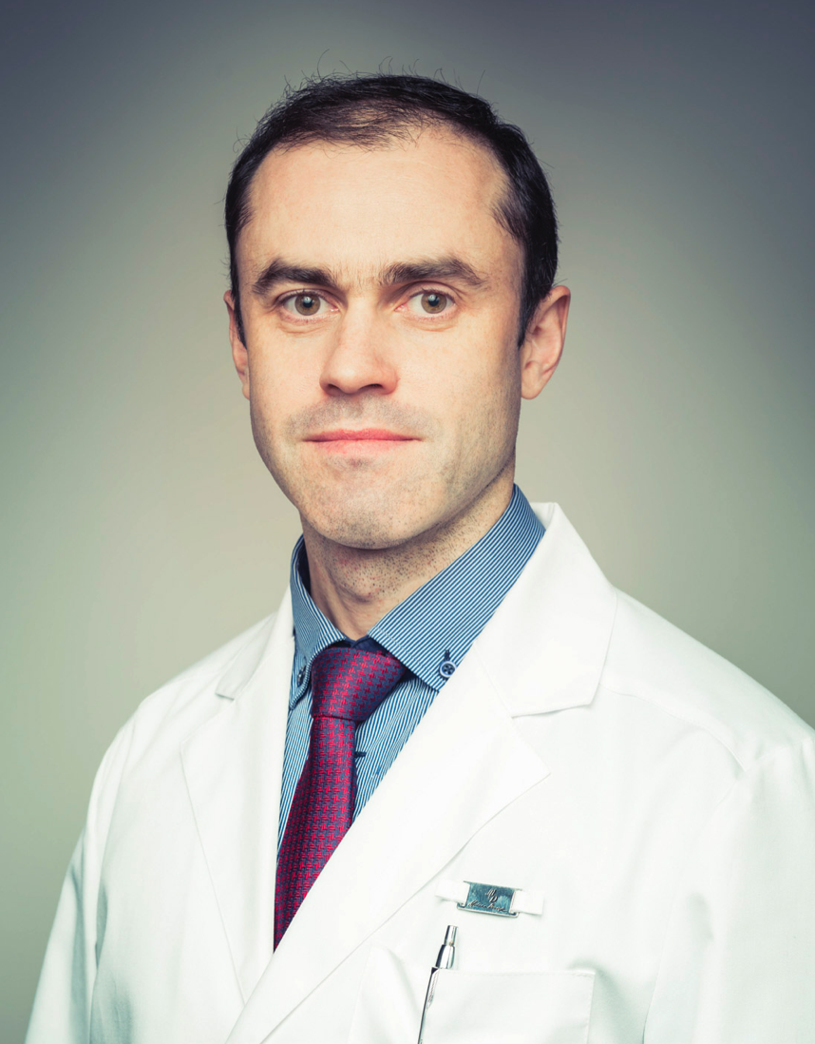  Research supervisor:  Dmitry S. Bobrov,  Candidate of Science/PhD Federal State Autonomous Educational Institution of Higher Education I.M. Sechenov First Moscow State Medical University of the Ministry of Health of the Russian Federation (Sechenov University) | Reconstructive Foot Surgery
Supervisor’s research interests (более детальное описание научных интересов):
Use of joint saving operations with the restoration of foot function in various congenital and acquired pathological changes.
Research highlights (при наличии):
Complex study of the structure, function, biomechanics of the foot using computer modeling of pathological changes with the creation of a personalized model of the patient's treatment.

Supervisor’s specific requirements:
- Graduated from a full basic course in traumatology and orthopedics. Understanding of foot biomechanics and treatment principles.

Supervisor’s main publications (указать общее количество публикаций в журналах, индексируемых Web of Science или Scopus за последние 5 лет, написать до 5 наиболее значимых публикаций с указанием выходных данных): 7

Bobrov D.S., Shubkina A.A., Lychagin A.V., и др. Surgical treatment of hammertoes (literature review) // Annals of the Russian academy of medical sciences. - 2019. - Т. 74. - №4. - C. 272-282. doi: 10.15690/vramn1096.
Serova N.S., Belyaev A.S., Bobrov D.S., Babkova A.A., Karev A.S. Role of functional MSCT in the diagnosis of elastic flatfoot deformity. REJR 2019; 9(2):301-314. DOI:10.21569/2222-7415-2019-9-2-301-314.
Лычагин А.В., Гаркави А.В., Ислейих О.И., Катунян П.И., Бобров Д.С., Явлиева Р.Х. и др. Эффективность внутрикостного введения аутологичной обогащенной тромбоцитами плазмы в зону отека костного мозга при остеоартрозе коленного сустава. Вестник РГМУ. 2019; (4): –. DOI: 10.24075/vrgmu.2019.053.
Serova N.S., Belyaev A.S., Bobrov D.S., Ternovoy K.S. Modern X-ray diagnosis of adult acquired flatfoot deformity. Vestnik Rentgenologii i Radiologii (Russian Journal of Radiology). 2017; 98 (5): 275–80 (in Russ.). DOI: 10.20862/0042-4676-2017-98-5-275-280.
Ternovoy S. K., Serova N.S., Belyaev A.S., Bobrov D. S., Ternovoy K. S. Methodology of functional multispiral computed tomography in the diagnosis of adult flatfoot. REJR. 2017; 7 (1):. DOI:10.21569/2222-7415-2016-6-4-38-43.
Bobrov D.S., Slinyakov L.Yu., Rigin N.V. Overload metatarsalgia: pathogenesis, biomechanics and surgical treatment (analytical literature review). Vestnik RAMS. 2017;72(1):53–58. doi: 10.15690/vramn756.
The role of baropodometry in assessment of pre- and postoperative condition of patients with overload metatarsalgia. "Russian Journal of Biomechanics". 2019.-Т.23, №4. С.500-510. L.Yu. Slinyakov and co-author. (Bogatov V.B., Rigin N.V., Bobrov D.S., Shubkina A.A.).
Bobrov DS, Rigin NV, Lychagin AV, Artemov KD, Slinjakov LJ, Kachesov AV. Surgical Treatment of Metatarsalgia and Severe Instability of Lesser Metatarsophalangeal Joints. J Foot Ankle Surg. 2023.
Kachesov AV, Nosov OB, Bobrov DS, Artemov KD, Lekic G. Clinical and biomechanics effects of modified Helal osteotomy with screw fixation in forefoot reconstruction. Int Orthop. 2023.
Results of intellectual activity (при наличии)
A system of simulated functional study of foot has been developed.
The principles of the joint saving operations in case of the pathology of metatarsophalangeal joints are developed.
The results of the research have been implemented in clinical practice.
New methods of treatment of avascular necrosis of talus bone are being developed.

