Sechenov University, Moscow
NEW!!! Master’s Degree Program in Linguistics
  - PSYCHOLINGUISTICS OF INTERCULTURAL COMMUNICATION
Open your mind to other cultures

A fully English-language program!

NEW!!! Master’s Degree Program in Linguistics
  - PSYCHOLINGUISTICS OF INTERCULTURAL COMMUNICATION
Program Overview

This master’s program provides knowledge and skills for successful participation in a dialogue with people from different cultural background. You will gain practical experience in applying various techniques and tools to identify, analyse and successfully solve intercultural communication prob-lems in a multicultural setting.
OUR MISSION
This innovative master’s program is to promote intercultural understanding in general, and in a professional setting in particular, enabling graduates to prevent intercultural misunderstandings and conflicts.

Core subjects:
- Theory of Intercultural Communication
- Ethnopsycholinguistics
- Cross-Cultural Psychology
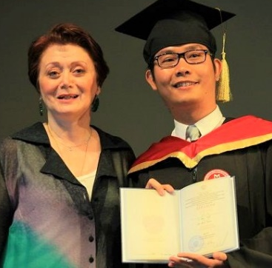
- Intercultural Business and Management
- Mass Media and Cross-Cultural PR
- Academic Writing
- Russian Culture
- Russian Language
- Elective: German/French

Russian Ethnopsycholinguistics
All linguists know how different the world may look through the prism of different languages. This difference sometimes makes us curious and attracted to an unknown culture, or may give ground to intercultural misunderstandings. The cause of misunderstanding is the dissimilar cultural or ethnic-specific images of the world investigated by Russian Ethnopsycholinguistics since the early 1970s. Based on the Theory of Linguistic Image of the World and the Lacuna Theory students will develop their own effective communication strategies to overcome barriers in the path of mutual understanding and cooperation.

The curriculum heavily relies on the works of leading Russian psycholinguists: Leont’ev, Sorokin, Tarasov, Ufimtseva, Markovina and fellow researchers.
Fast facts
Entry term: Autumn 2017
Number of courses: 12
Number of semesters: 4
Typical course load:
- 1st& 2nd semester: 4-4 courses
- 3rd semester: 1 course and Internship/or 2 courses
- 4th semester: 1 practical course and writing &defence of thesis

Irina Markovina, Ph.D., Professor, Head of Foreign Languages Dept.
Natalya Ufimtseva, D.Sc., Professor, Institute of Linguistics
Paul Adams, Ph.D. Professor Emeritus (USA)
Istvan Lenart, Ph.D. Associate Professor (Hungary)
Igor Mokin, Ph.D. Associate Professor
Jonathan McFarland, Head of Academic Writing Office (UK)

Career opportunities
Graduates will be able to operate in an international context, in any field where intercultural skills are in demand. They will be qualified for employment in the international job market in both public and private sector, including working for:

- international organizations
- public administration
- education
- multinational companies
- trade
- tourism
- local, national governments
- international research projects
- other fields where intercultural sensitivity is a key requirement.

Gaining this Master’s Degree may also serve as a springboard into further studies of Intercultural Communication and obtaining a PhD degree (Candidate of Science in Linguistics) from the Institute of Linguistics of the Russian Academy of Science.
Contact
www.sechenov.ru/psycholinguisticsIC
Facebook: www.facebook.com/groups/psycholinguisticsIC
VKontakte: www.vk.com/psycholinguisticsIC
Email: istvan.lenart@1msmu.ru
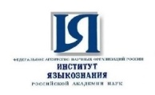
Sechenov University, Institute of Linguistics Russian Academy of Sciences

