**Department**

Olga Y.Olisova, MD, PhD, professor, Corresponding Member of the Russian Academy of Sciences, Head of Department of Skin and Venereal Diseases

https://www.sechenov.ru/univers/about_lecturer/368/

**Scientific interests**: Dermatovenerology

**Research project:**

Comorbid conditions in hidradenitis suppurativa

**Topics and content of the research project:**

Comorbid conditions in hidradenitis suppurativa

Supervisor - Natalia P.Teplyuk , PhD, Professor at the Department of Skin and Venereal Diseases

https://www.sechenov.ru/univers/about_lecturer/99488/

Working languages: Russian, English

**Aims and Objectives of the research project:**

Objective.

Develop an algorithm for examining patients with purulent hidradenitis based on the identified comorbidities

Tasks.

1. Study the incidence of gastrointestinal diseases in purulent hidradenitis

2. Study the incidence of endocrine diseases in purulent hidradenitis

3. Study the incidence of polycystic ovary syndrome in purulent hidradenitis

4. Study the incidence of skin lesions by other skin pathologies in purulent hidradenitis

5. Conduct a study of the correlation between the incidence of comorbid conditions with the stage of purulent hidradenitis and the phenotype

**Position Description:**

Objectives:

1. Carrying out a scientific research

2. formalising the results of the project

3. training in the implementation of the research project

4. Publicising the work and publishing the results

Functions:

1. Working with information

2. Collecting and analysing research data

3. Conducting a clinical trial

4. Publication of results

Report preparation and presentation

Salary, position, contract term: 0.5-1.0 of the rate; senior research fellow; 1 year.

Salary: 40-100 thousand rubles (based on interview results).

Requirement for a postdoc: more than 5 publications in Q2-Q1 journals, CV, work experience:

publications in Q1/2 journals within the last 3 years

English at least C1

Expected work results: patents, datasets, publications in Q1/2 journals, conference presentation

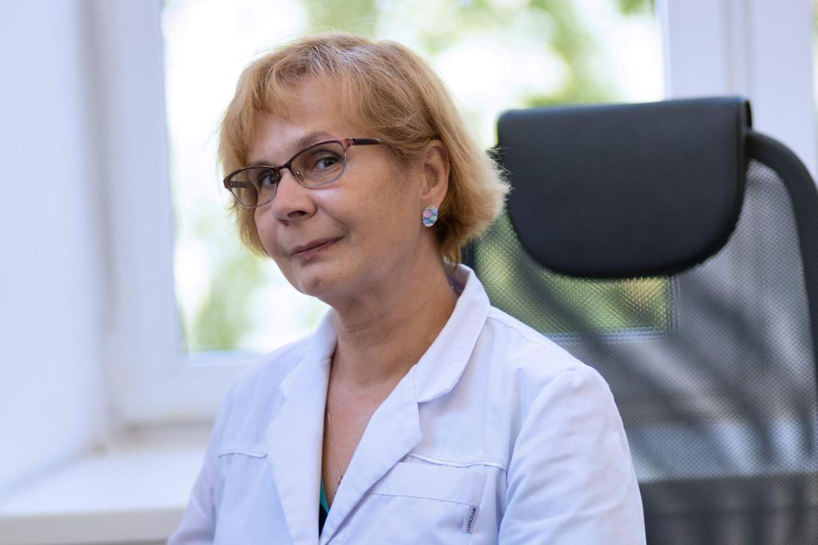

**Natalia P.Teplyuk**

Ph.D, Professor at the Department of Skin and Venereal Diseases

Scientific and pedagogical experience of 36 years.

Scientific interests: skin pathomorphology, bullous dermatoses, hidradenitis suppurativa

https://elibrary.ru/author_profile.asp?id=449736

https://www.scopus.com/authid/detail.uri?authorId=9839218300

**Topics and content of research project and educational activities**

Comorbid conditions in hidradenitis suppurativa

**Supervisor’s main publications**

Shlyk, D. D., Pikuza, M. N., Kitsenko, Yu. E., Pirogova, A. S., Paramonova, N. B., Rzaev, R. T., Tsarkov, P. V. (2023). Follicular occlusion syndrome is a possible variant of the follicular retention origin of the epithelial coccygeal course. Russian Journal of Gastroenterology, Hepatology, Coloproctology, 33(6), 53-64.

Olisova, O. Yu., Grabovskaya, O. V., Teplyuk, N. P., Bobkova, A. E., Tavitova, A. R., Kusraeva, D. T., Myshlyanova, D. A. (2024). On the issue of the syndromic forms of gangrenous pyoderma. Russian Journal of Skin and Venereal Diseases, 27(4), 419-434.

Grabovskaya, O. V., Teplyuk, N. P., Kusraeva, D. T., Varshavsky, V. A. (2019). A case of clinical observation of gangrenous pyoderma. Russian Journal of Skin and Venereal Diseases, 22(5-6), 161-166. Kuznetsov, A.V., Plotnikov, A. A., Obolensky, V. N., Pirogova, A. S., Teplyuk, N. P., Leval, P. S., Grigoryan, G. A. (2024). Simultaneous radical surgical treatment of purulent stage III hydradenitis according to the Hurley classification of axillary localization with wound repair with a posterior shoulder flap (clinical observation). Wounds and wound infections. The journal named after Prof. B. M. Kostyuchenko, 11(2), 36-43. Teplyuk, N. P., Konchina, S. A., Pirogova, A. S. (2023). The experience of treating a patient with follicular occlusion syndrome with tumor necrosis factor alpha inhibitors.

Teplyuk, N. P., Pirogova, A. S. (2022). Photo gallery. Purulent hydradenitis (inverse acne). Russian Journal of Skin and Venereal Diseases, 25(4), 337-340. Teplyuk, N. P., Pirogova, A. S., Svistunova, D. A. (2023). Photo gallery. Follicular occlusion syndrome. Russian Journal of Skin and Venereal Diseases, 26(1), 95-100. Shlyk, D. D., Ilyukhina, Yu. A., Pirogova, A. S., Kitsenko, Yu. E., Tulina, I. A., Teplyuk, N. P., Tsarkov, P. V. (2022). Follicular occlusion syndrome in the practice of a coloproctologist. Russian Medical Journal, 28(6). Teplyuk, N. P., Grabovskaya, O. V., Kusraeva, D. T., Grekova, E. V., Koryakin, D. A., Kostenko, A. Yu. (2022). Successful treatment of gangrenous pyoderma associated with ulcerative colitis against the background of a new coronavirus infection COVID-19: a clinical case. Russian Journal of Skin and Venereal Diseases, 25(5), 373-380.

**Experience of scientific supervision**

Under his guidance, 8 dissertations for the degree of PhD were defended. Currently, 3 graduate student approbations have been completed, 2 track residents

Dermatovenerology, skin pathomorphology, bullous dermatoses, hidradenitis suppurativa

**Teaching Experience**

Course list:

Dermatovenerology, skin pathomorphology, bullous dermatoses, hidradenitis suppurativa