Symposium

**Personalized Oncology:**

**Through the View of Idea, Practice, Health and Translational Pipelines**

Moscow October 12, 2017

**10.00-10.15 OPENING**

**Introductory**

**10.15-10.45**

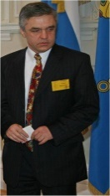**Sergey Suchkov**

**Personalized Medicine (PM) through the View of Modern Philosophy to suit Healthcare Model and Translational Armamentarium to secure the latter: from The Past through the Future**

Center for Personalized Medicine, I.M.Sechenov First Moscow State Medical University (Sechenov University) and Dept for Translational Medicine, Moscow Engineering Physical Institute (MEPhI), Russia; EPMA, Brussels, EU; PMC & ACS, Washington, DC, USA; ISPM, Tokyo, Japan

**10.45-11.15**

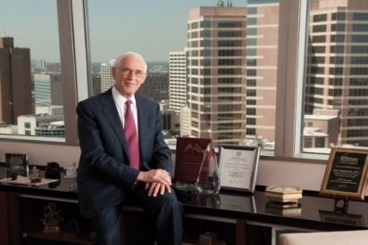**John Mendelsohn**

**Precision Cancer Medicine: Achievements and Prospects**

Institute of Personalized Cancer Therapy & Department of Genomic Medicine, University of Texas MD Anderson Cancer Center, Houston, USA

**Fundamentals of Personalized and Precision Medicine**

**11.20-11.40**

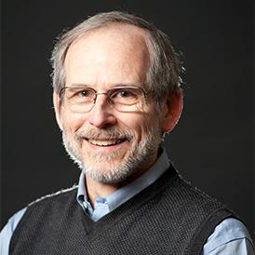**Roger Kamm**

**Microfluidic technologies for drug screening, point-of-care assays, and disease models: Applications to cancer**

Mechanobiology & Microfluidics Laboratory and NSF Science and Technology Center on Emergent Behaviors of Integrated Cellular Systems, MIT, Cambridge, MA, USA

**11.40-12.00**

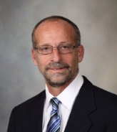**David Smith**

**Whole genome sequencing strategies for the treatment of patients with oropharyngeal squamous cell carcinoma**

Department of Laboratory Medicine and Pathology and Chairman, Technology Assessment Group, Center for Individualized Medicine, Mayo Clinic, Rochester, MN, USA

**12.00-12.20**

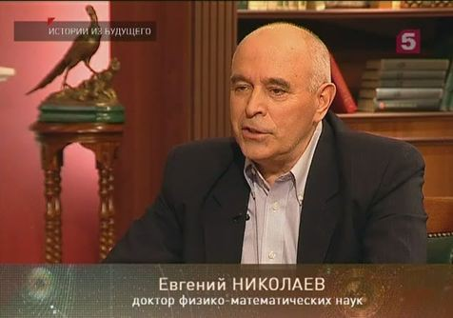**Evgenyi Nikolaev**

**Proteomics as applicable to Oncology**

Skolkovo Institute of Science and Technology, Moscow region, Moscow Institute of Physics and Technology, Dolgoprudnyj, Moscow region, Institute for Energy Problems of Chemical Physics Russian Academy of Sciences, Moscow

**12.20-12.40**

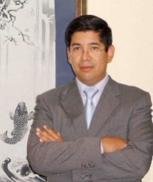**Carlos Malpica**

**Precision Metabolomics applied to Personalized Oncology**

Metabolon Inc., Madrid, Spain

**12.40-13.00**

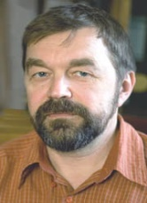**Nikolai Bovin**

**Personalized oncology through the View of The Diagnostic and Therapeutic Resources of the Newest Generation**

Division for Chemical Biology of Glycans and Lipids, Institute of Bioorganic Chemistry, Russian Academy of Sciences, Moscow, Russia, and CSO, KODE Biotech, Auckland, New Zealand

**13.00-13.20**

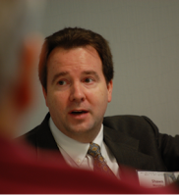**Shawn Murphy**

**Integrating Genomic and Clinical Data for Precision Medicine**

Harvard Medical School, Research Information Systems and Computing, Partners HealthCare and Massachusetts General Hospital, Boston, MA, USA

**Modern Clinical Models in Personalized Oncology**

**13.20-13.40**

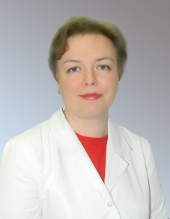**Marina Sekacheva**

**Personalized Treatment to target colorectal cancer 2.0: from RAS through Multitargeting**

Center for Personalized Oncology, I.M.Sechenov First Moscow State Medical University, Moscow, Russia

**13.40-14.00**

**Vladimir Lazar**

**Development and validation of a new technology and biomarker strategy to predict the efficacy of combinations of targeted cancer therapies: The Model of Lung Cancer**

WIN Consortium, Paris, France

**14.00-14.20**

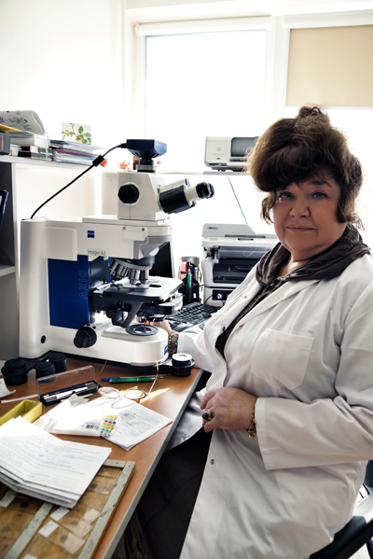**Evgeniya Kogan** and **Sofia Demura**

**Pathomorphology and Its Armamentarium as applicable to Personalized Oncology: Diagnostic, Predictive and Prognostic Protocols to Monitor Lung Cancer Development**

I.M.Sechenov First Moscow State Medical University and Aston Group, Moscow,Russia

**14.20-14.40**

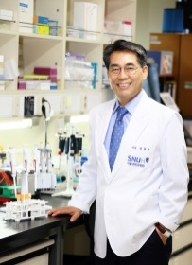**Chui Woo Kim**

**Smart Cancer Screening: A Tool for Personalized Medicine**

Bioinfra and Professor, Seoul National University (SNU) and SNU College of Medicine Research Center,

Seoul, South Korea

**14.40-15.00**

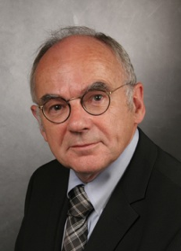**Hans Lentzen**

**From an Attractive Academic Idea and Promising Pharma Model through a step of Basic Research and Translational Bridging to suit Precision medicine – an example for Interdisciplinary Cooperation in Personalized Oncology**

MELEMA Pharma GmbH, Hamburg-Cologne, Germany

**CLOSING**